Approximation algorithms for multiple sequence alignment under a fixed evolutionary tree
R. Ravi John D. Kececioglu
Discrete Applied Mathematics p.355~366 1998
Abstract
An approximation algorithm for multiple sequence alignment under a fixed evolutionary tree which solves the problem in polynomial time. The author also introduces a new problem called bottleneck tree-alignment.
- Introduction
Given a tree whose leaves are labeled by sequence, find ancestral sequences to label its internal nodes so as to minimize the total length of the tree. The author presents a new polynomial–time approximation algorithm for this problem, and analyzes its performance on regular d-ary trees with d a constant.
The author also introduces a new problem, bottleneck tree-alignment, in which the objective is to label the internal nodes of the tree so as to minimize the length of the longest edge.
- Classical tree alignment
Steiner problem : Given sequences 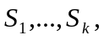 find a sequence P that minimizes the sum 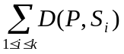, where 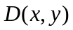 denotes the edit distance between sequences x and y. Sequence P is called a Steiner sequence for the multiset.

Approximation algorithm
*The first phase computes a Steiner sequence for every q-subset of leaves of T for all qp. Let the set of these Steiner sequences be 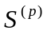.
*In the second phase, the algorithm finds an optimal labeling of the internal nodes of T, using labels drawn from .

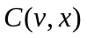 : The minimum cost of all labelings of the subtree rooted at where is labeled by .
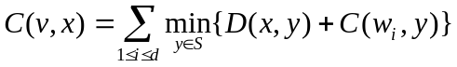
Performance guarantee on regular d-ary tree :
The algorithm finds a solution within a factor 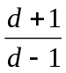 of the minimum in 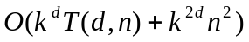 time. Where k is the number of the leaves in the tree, n is the length of the longest sequence labeling a leave, and 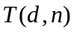 is the time to compute a Steiner point for d sequences of length at most n.
- Bottleneck tree-alignment
Exact algorithm (on star-tree) : Brute force
Approximation algorithm : We simply labels each internal node with the sequence of its nearest leaf.
Lemma
- Open problems
Is there a method to solve bottleneck tree-alignment, perhaps avoiding dynamic programming, which uses considerably less time and space?
Created by : Rei-Sing Cheng
Date : Mar 5, 2002

